Experiment: Property Buying and Rental System using Zoho Creator (SaaS)
Aim
To design and develop a Property Buying and Rental System using Zoho Creator, a cloud-based SaaS platform, that enables users to register property details, calculate the total property cost or rental amount, and maintain property records efficiently.
Procedure
Step 1:
Log in to Zoho Creator.
Step 2:
Click Create New Application.
Step 3:
Enter the application name as: Property Buying and Rental System
Step 4:
Create a form named: Property Details
Step 5:
Add the following fields:
Field Name | Field Type
Customer Name | Name
Phone Number | Phone
Property Name | Single Line
Property Type | Drop Down
Location | Single Line
Cost | Currency
Number of Months | Number
Total Amount | Currency
Step 6:
Create a workflow to calculate the total amount.
if(input.COST != null && input.NUMBER_OF_MONTHS != null)
{
input.TOTAL_AMOUNT = input.COST * input.NUMBER_OF_MONTHS;
}
Step 7:
Create an On Success workflow to display a confirmation message. “alert "🏠 Property Booking Successful!\nThank you for choosing our service."”;
Step 8:
Create a report named: Property Report to display all property booking records.
Step 9:
Run the application, enter property details, submit the form, and verify that the total amount is calculated automatically and the confirmation message is displayed.
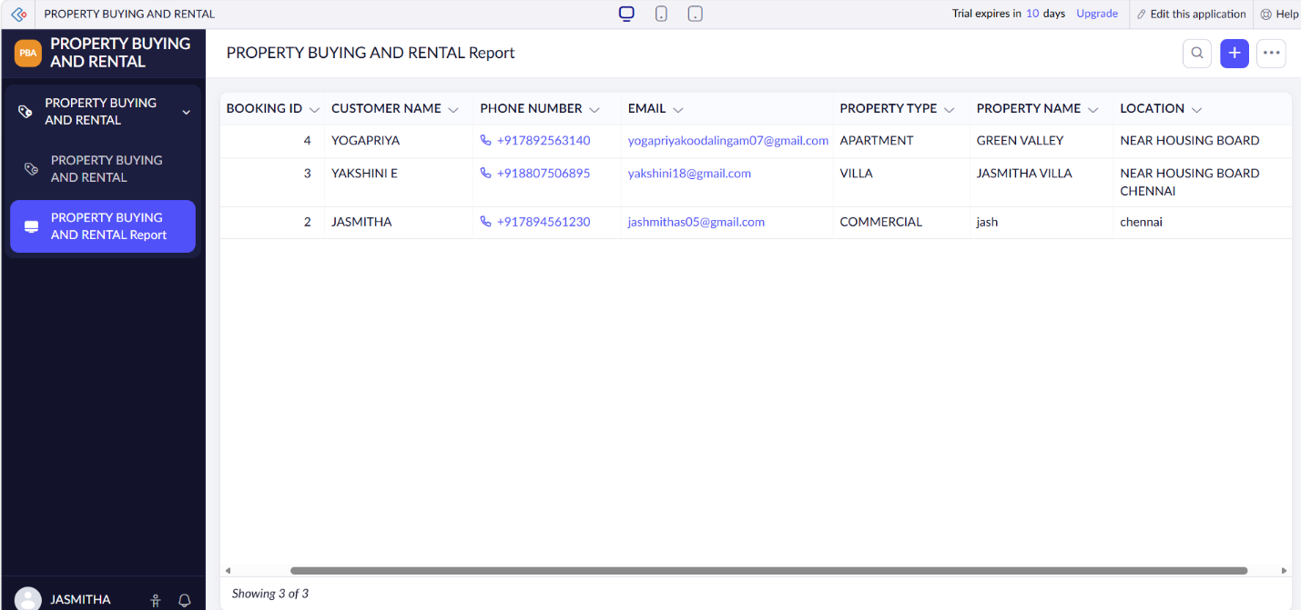
Implementation
The Property Buying and Rental System was implemented using Zoho Creator forms, workflows, and reports. The system allows users to enter customer information, property details, location, property cost, and rental duration. The total amount is automatically calculated based on the property cost and number of rental months using a workflow. After the property booking is successfully completed, a confirmation message is displayed to the user. All property booking details are securely stored in the Zoho Creator cloud database, and reports are generated to manage property records efficiently.

